PRACTICAL 12
- Implement the Producer-Consumer problem using counting semaphores and POSIX threads. Evaluate synchronization correctness and system throughput under different buffer sizes.

Design a deadlock scenario involving multiple threads competing for shared resources. Demonstrate deadlock occurrence, identify the four necessary conditions for deadlock, and implement a deadlock prevention strategy using resource ordering.
SOL:-
1) producer_consumer.c
#include <stdio.h>
#include <stdlib.h>
#include <pthread.h>
#include <semaphore.h>
#include <unistd.h>

#define BUFFER_SIZE 5
#define PRODUCE_COUNT 10

int buffer[BUFFER_SIZE];
int in = 0, out = 0;
sem_t empty, full;
pthread_mutex_t mutex;

void* producer(void* arg) {
for (int i = 0; i < PRODUCE_COUNT; i++) {
int item = i+1;
sem_wait(&empty);
pthread_mutex_lock(&mutex);
buffer[in] = item;
printf("Produced %d\n", item);
in = (in+1) % BUFFER_SIZE;
pthread_mutex_unlock(&mutex);
sem_post(&full);
sleep(1);
}
return NULL;
}

void* consumer(void* arg) {
for (int i = 0; i < PRODUCE_COUNT; i++) {
sem_wait(&full);
pthread_mutex_lock(&mutex);
int item = buffer[out];
printf("Consumed %d\n", item);
out = (out+1) % BUFFER_SIZE;
pthread_mutex_unlock(&mutex);
sem_post(&empty);
sleep(1);
}
return NULL;
}

int main() {
pthread_t prod, cons;
sem_init(&empty, 0, BUFFER_SIZE);
sem_init(&full, 0, 0);
pthread_mutex_init(&mutex, NULL);

pthread_create(&prod, NULL, producer, NULL);
pthread_create(&cons, NULL, consumer, NULL);

pthread_join(prod, NULL);
pthread_join(cons, NULL);

sem_destroy(&empty);
sem_destroy(&full);
pthread_mutex_destroy(&mutex);
return 0;
}
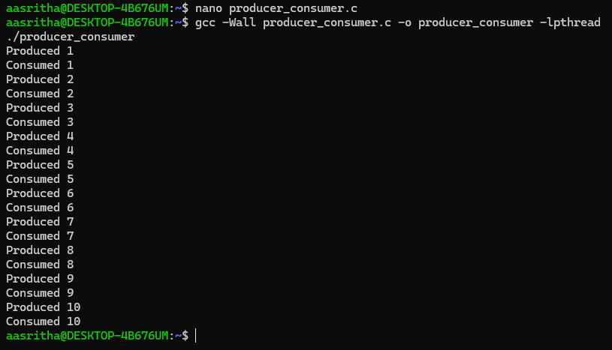
2) deadlock_demo.c
#include <stdio.h>
#include <stdlib.h>
#include <pthread.h>
#include <unistd.h>

pthread_mutex_t lock1, lock2;

void* thread1(void* arg) {
pthread_mutex_lock(&lock1);
sleep(1); // simulate work
pthread_mutex_lock(&lock2);
printf("Thread1 acquired both locks\n");
pthread_mutex_unlock(&lock2);
pthread_mutex_unlock(&lock1);
return NULL;
}

void* thread2(void* arg) {
pthread_mutex_lock(&lock2);
sleep(1); // simulate work
pthread_mutex_lock(&lock1);
printf("Thread2 acquired both locks\n");
pthread_mutex_unlock(&lock1);
pthread_mutex_unlock(&lock2);
return NULL;
}

int main() {
pthread_t t1, t2;
pthread_mutex_init(&lock1, NULL);
pthread_mutex_init(&lock2, NULL);

pthread_create(&t1, NULL, thread1, NULL);
pthread_create(&t2, NULL, thread2, NULL);

pthread_join(t1, NULL);
pthread_join(t2, NULL);

pthread_mutex_destroy(&lock1);
pthread_mutex_destroy(&lock2);
return 0;
}
